**Day 1**

**What to do?**

Learn exactly what is Deep Learning, difference between AI, ML, and DL. History of neural networks.

**Deep Learning:**

* subfield of machine learning that is inspired by the way our brain works and functions.
* Basically, huge neural network – many hidden units and hidden layers
* According to Andrew Ng, idea of deep learning was to use brain simulations to make learning algorithms better and easier to use and make revolutionary advances in AI.
* With the huge computational power these days, DL has been making advances in speech, image and behavior recognition.

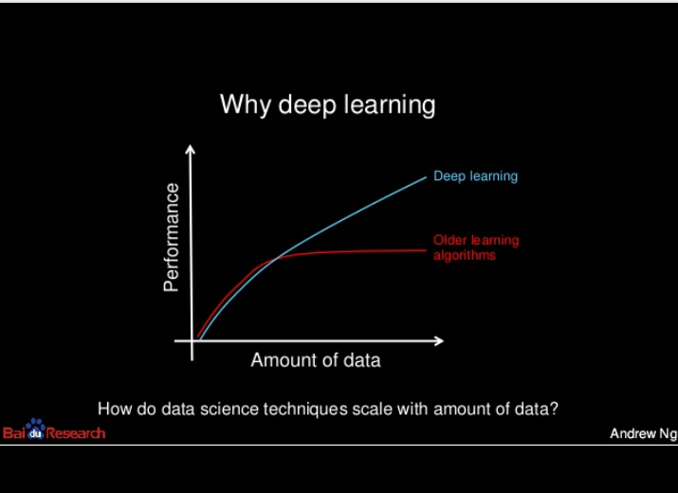

**Difference between AI, ML and DL:**

While AI is the practice of a machine performing better than a human, its intelligence comes from machine learning algorithms. However, the initial ML algorithms were too prone to error when it came to complex problems like computer vision. Hence, the deep learning – large neural network that learns from huge amount of data to think like a human.

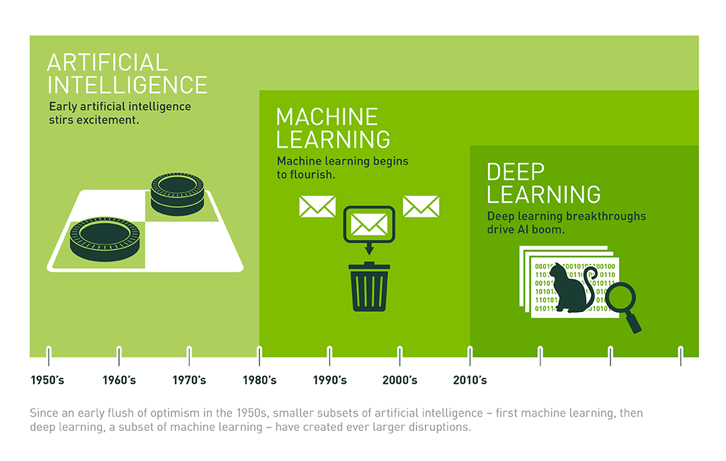

**Current/Future AI:**

Self-driving cars, movie recommendations, facial recognition, preventive measures in healthcare, many more.